Shutdown Circuit

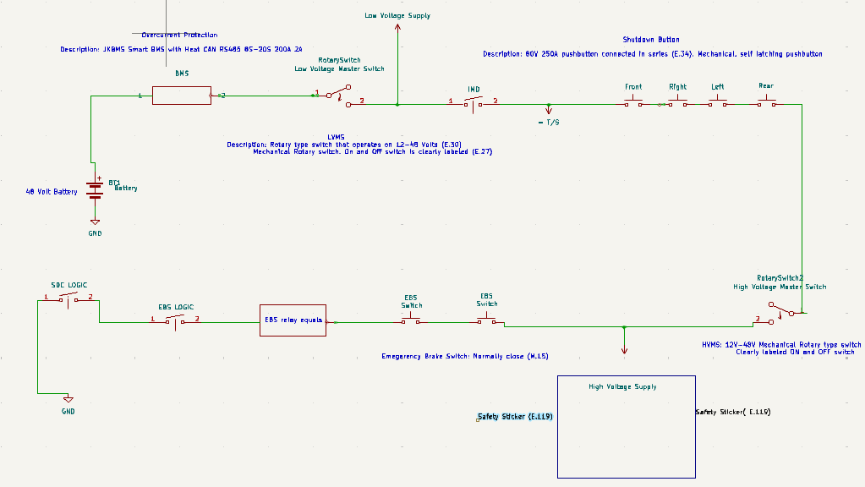
- Our system will utilize a Low Voltage Battery.

- For the overcurrent protection itself we have chosen to use a JKBMS Smart BMS. The BMS will be connected to the Low Voltage Battery in series (E.34). The BMS has an input voltage of 60V (E.50).
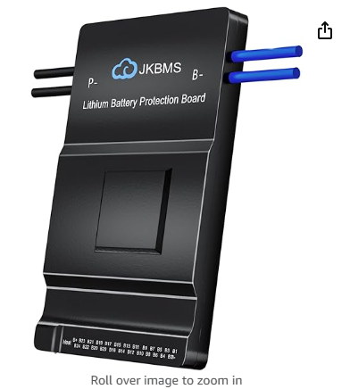

Link: https://www.amazon.com/dp/B0D1C81JSC?ref=cm_sw_r_cso_cp_apin_dp_PJH8DSSJZK5XHG5MZG3C&ref_=cm_sw_r_cso_cp_apin_dp_PJH8DSSJZK5XHG5MZG3C&social_share=cm_sw_r_cso_cp_apin_dp_PJH8DSSJZK5XHG5MZG3C&peakEvent=5&starsLeft=1&skipTwisterOG=1&th=1

- In series with the overcurrent protection is the Low voltage and High voltage master switch (E.34). We have chosen to use a rotary type switch that operates on 12-48 Volts, complying with rule E.30. Additionally, the rotary switch On and Off switch is clearly labeled, complying with rule E.27.

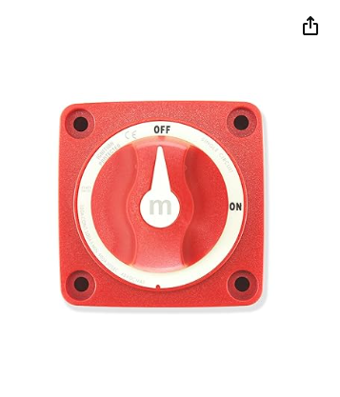

Link: https://www.amazon.com/Bhanboth-Battery-Disconnect-Switch-12v/dp/B0D9YR1ZGF/ref=sr_1_6?crid=2IA9DNY3P4EBO&dib=eyJ2IjoiMSJ9.4TxMIpc5ER8eQi3ZNNBg-02XtzMQ-bb2W-rCndp7TWAIHgCQl5aiLKAnJGzjT3crnZprM6QqsevYOtzV2dsdTPCCd-cRReWQHupgxwq61XlqMCjKPfGPBbWg3kIkT2e2OMm2teryfviZywiPHdlsU0Zy5xxP7cwSuuCVfkT2OHxKnWqjTvToprjFKduga85113Fo0VLN9CMKJmRAGAsGOsBBi8xwpTbZ9sJKVLfEdKw.hbUkzHoFTMQ4yT-HIhlWWdKtpoYUfX0aP4WpXaYaQ1U&dib_tag=se&keywords=rotary+power+switch+48v&qid=1733432979&sprefix=rotary+power+switch+48v%2Caps%2C209&sr=8-6

- For the four shutdown buttons, we will be using an 80V 250A, a latching mechanical push button switch (E.43). The shutdown buttons will be placed on the rear, front, right, and left side of the vehicle. The mechanical pushbutton has a diameter greater than 40mm, with a red top (E.43). And the 80V 250A push button will be connected in series (E.34).
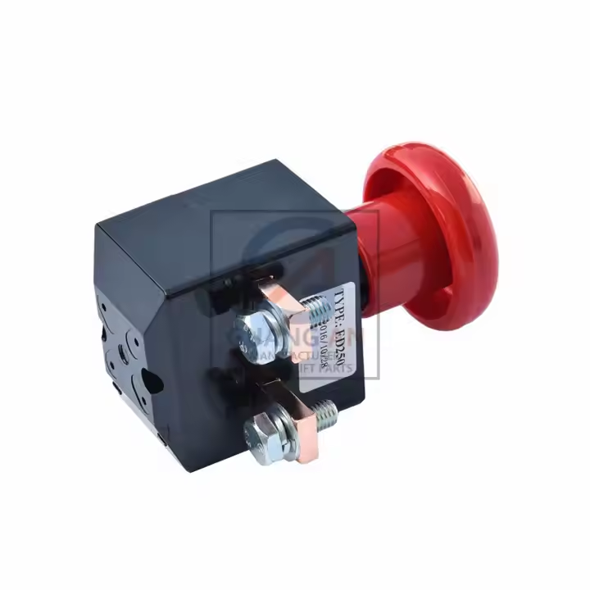
Link: https://www.alibaba.com/product-detail/Wholesale-80V-250A-Mechanical-Push-Button_1600154668513.html?spm=a2700.details.you_may_like.1.1ad141c21v9uR8

- Recommended hazard stickers for the high voltage system, following (E.119) protocol, with visible high voltage sign (E.119).

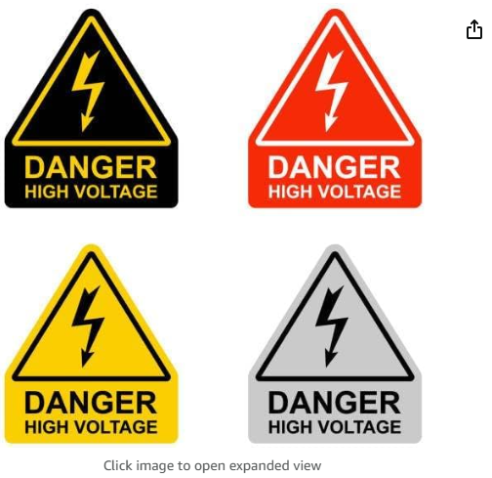

Link:https://www.amazon.com/dp/B0CTBJK6B9/ref=sspa_dk_detail_5?psc=1&pd_rd_i=B0CTBJK6B9&pd_rd_w=mnCyo&content-id=amzn1.sym.7446a9d1-25fe-4460-b135-a60336bad2c9&pf_rd_p=7446a9d1-25fe-4460-b135-a60336bad2c9&pf_rd_r=63CKAFDZQ6BN9DWZ699F&pd_rd_wg=ucmG7&pd_rd_r=b6a074af-454c-43a7-aafc-4ca0a42abe9e&s=office-products&sp_csd=d2lkZ2V0TmFtZT1zcF9kZXRhaWw

- For our Emergency Brake Switches, we have chosen to use a normally closed heavy Duty 300A Battery On/Off Switch (M.15).

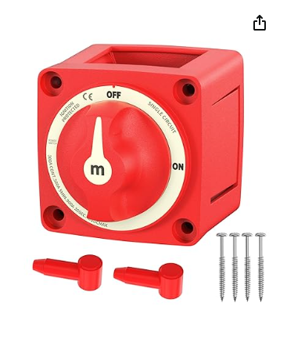

Link: https://www.amazon.com/dp/B0D9GFX7CG/ref=sspa_dk_detail_1?pd_rd_i=B0D9GFX7CG&pd_rd_w=JfNNi&content-id=amzn1.sym.8c2f9165-8e93-42a1-8313-73d3809141a2&pf_rd_p=8c2f9165-8e93-42a1-8313-73d3809141a2&pf_rd_r=8MNPEQ1YYQAP9C9TVC1B&pd_rd_wg=cmLU9&pd_rd_r=d3f00c3e-af3b-4079-816d-c5d241cf07cc&s=sporting-goods&sp_csd=d2lkZ2V0TmFtZT1zcF9kZXRhaWw&th=1

